# Task Phase Week 2 Answers (Python)

-Anirudh Agrawal

(Reg.No.: 220953044)

1] Write a program to iterate the first 10 numbers and in each iteration, print the sum of the current and previous number.

#Code:

for i in range(11):

    if i==0:

        print("The previous number is 0 and the current numbe is 0 and the sum is: 0")

    else:

        print("The previous number is",i-1,"and the current numbe is",i,"and the sum is:",i+(i-1))

#Output:

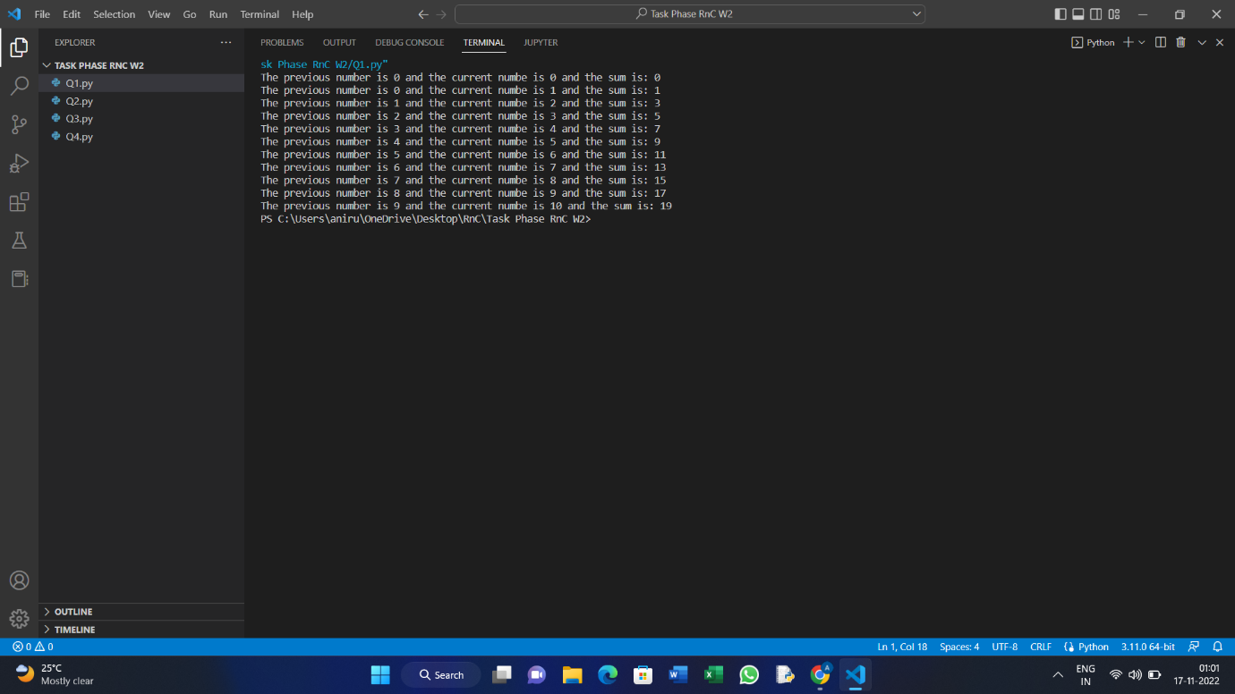

Q2] Print characters from a string that are present at an even index number.

#Code:

s=input("Enter a string:")

for i in range(len(s)):

    if i%2==0:

        print(s[i],end="")

#Output:

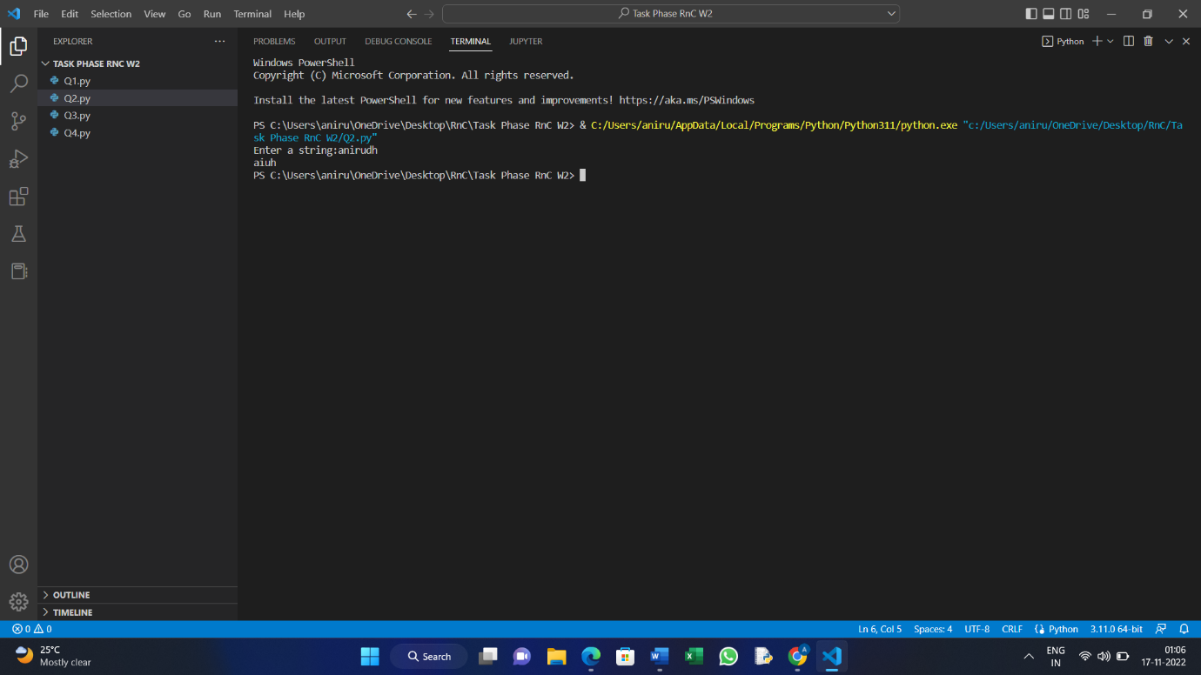

Q3] Reverse a string using the slice operator.

#Code:

s1=input("Enter a string:")

s2=s1[len(s1)::-1]

print("The reversed string is:",s2)

#Output:

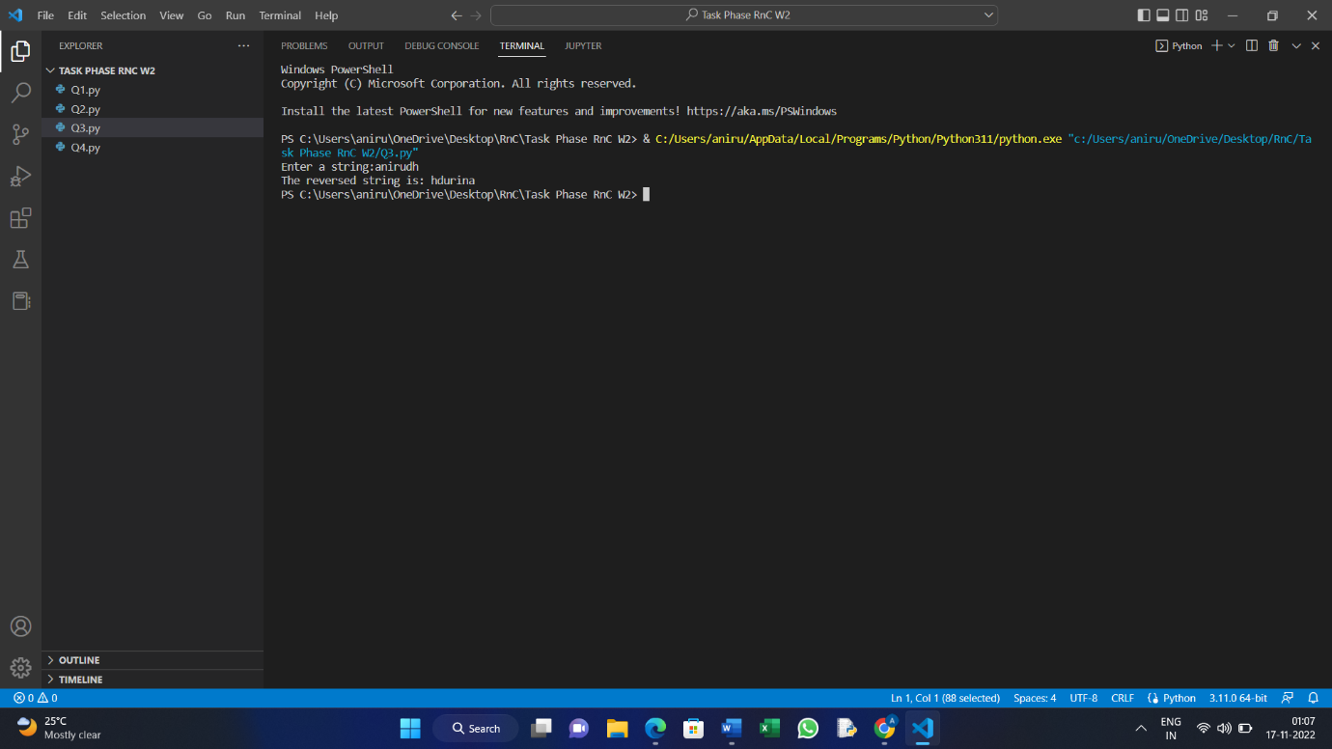

Q4] Count the frequency of every element of a list and store it in a dictionary.

Every element’s frequency should be printed only once.

Example:

If the list is [1,3,2,2,1,2,3,0,0]

Output: {1:2, 3:2, 2:3, 0:2}#Code:

lst=[1,3,2,2,1,2,3,0,0]

dic={}

for i in lst:

    if i not in dic:

        dic[i]=1

    else:

        dic[i]=dic[i]+1

print("List is:",lst)

print("Count is:",dic)

#Output:

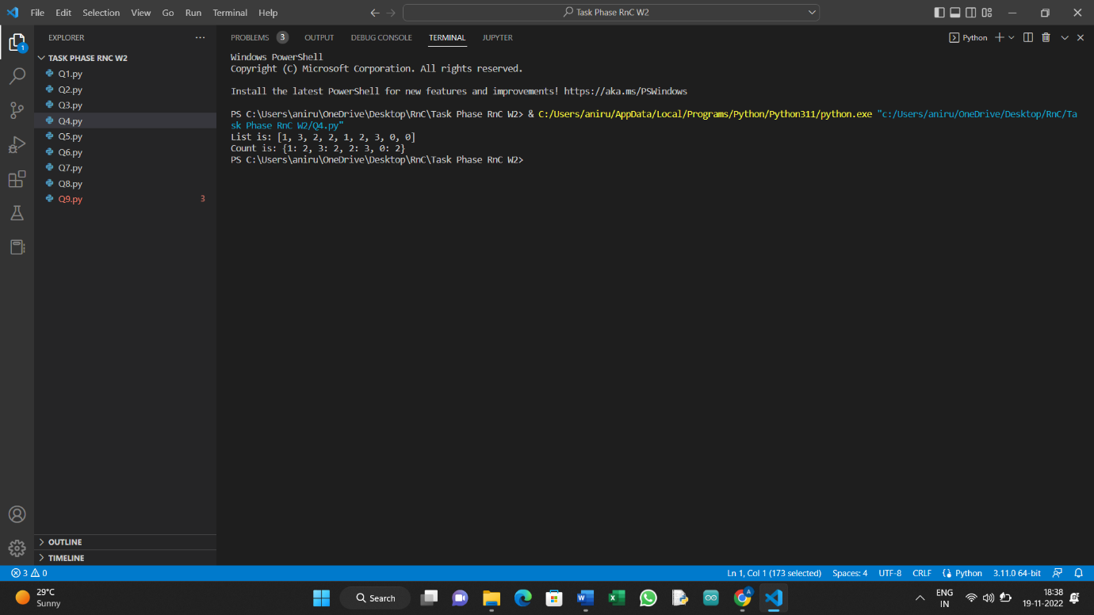

Q5] Take an input from the user in a single line (numbers are space separated) and print the sum. Input should be taken exactly the way shown below. Don’t give a prompt asking for an input(as shown)

Example:

Input: 1 3 4 5 6

Output: Sum is 19

#Code:

s1=input("Enter numbers (enter all the numbers at once using spces):")

s2=s1.split()

sum=0

for i in s2:

    x=int(i)

    sum=sum+x

print("The sum of entered numbers is:",sum)

#Output:

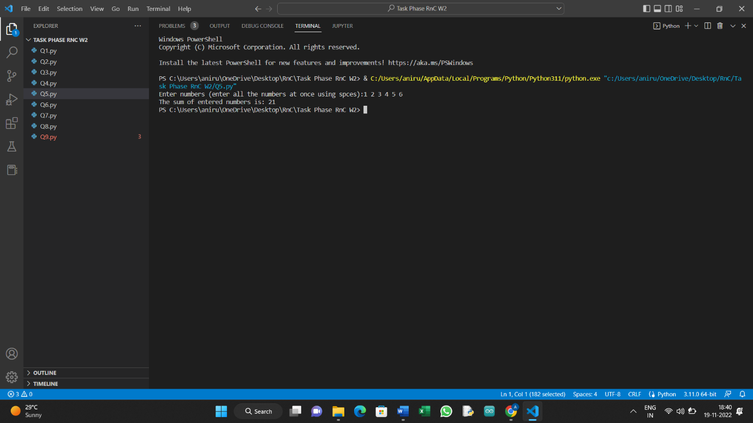

Q6] Remove empty strings from a list of strings. Example: [“hi”,””,”hello”,””] should give [“hi”,”hello”] as the output.

#Code:

l1=["hi","","Hello",""]

l2=[]

l3=[]

for i in l1:

    if i=="":

        l2.append(i)

    else:

        l3.append(i)

print("List is:",l1)

print("The updated list is:",l3)

#Output:

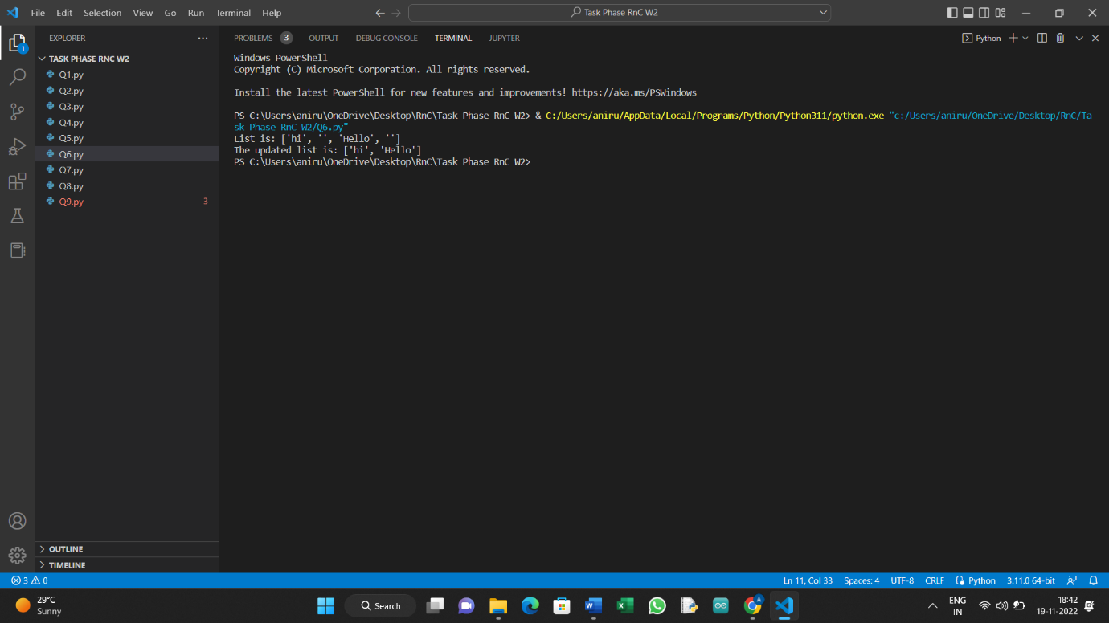

Q7] Reverse a tuple(same tuple. Do not use another tuple or list).

#Code:

tup=(1,2,3,4,5,6,7,8,9,10)

tup2=sorted(tup,reverse=True)

print("Initial tuple was:",tup)

print("Reversed tuple is:",tup2)

#Output:

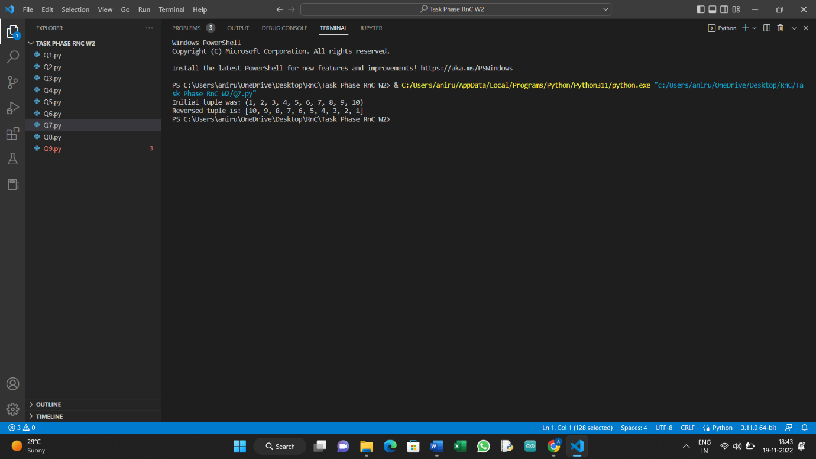

Q8] Sort a tuple of tuples based on the second element. Example: ((‘x’,45),(‘y’,12),(‘z’,20)) should give ((‘y’,12),(‘z’,20),(‘x’,45)) as the output.

#Code:

tup=(('x',45),('y',12),('z',20))

lst=[]

for k,v in tup:

    lst.append((v,k))

    x=sorted(lst)

print("Initial tuple was:",tup)

print("Sorted tuple is:",tuple(x))

#Output:

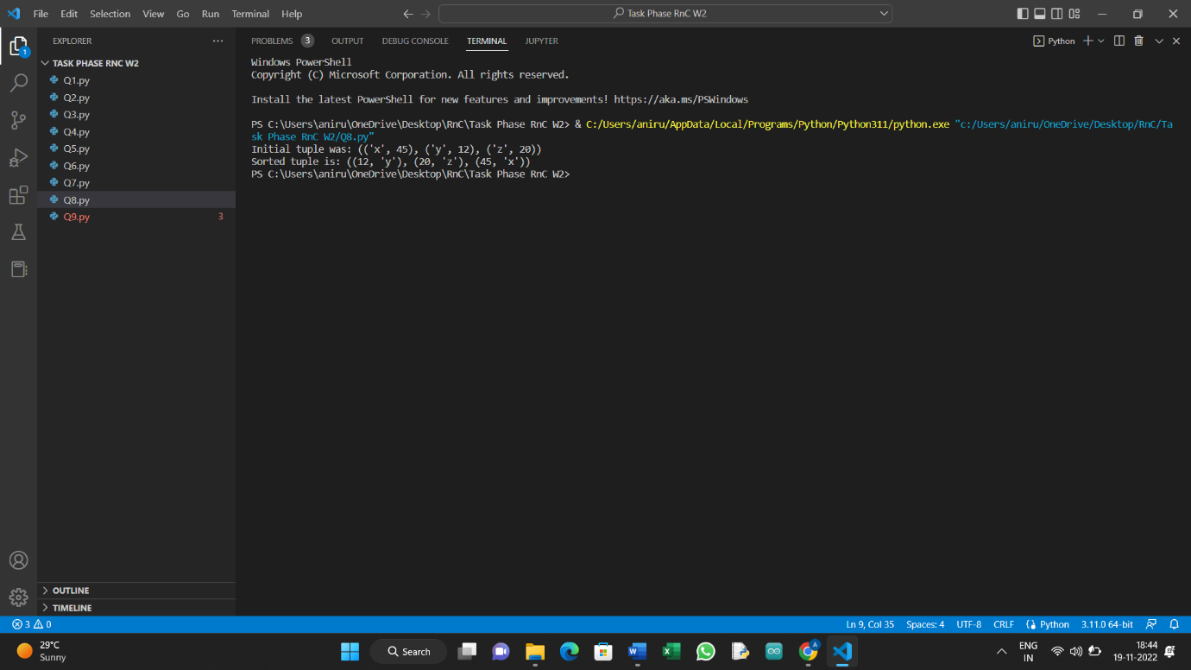

Q9] Check if all items in a tuple are different. Example: [1,2,5,7,4] prints True whereas [1,2,5,7,1,4] prints False.

#Code:

tup1=(1,2,5,7,4)

tup2=(1,2,5,7,1,4)

count={}

count2={}

for i in tup1:

    if i not in count:

        count[i]=1

    else:

        count[i]=count[i]+1

for i in tup2:

    if i not in count2:

        count2[i]=1

    else:

        count2[i]=count2[i]+1

for i in tup1:

    if count[i]>1:

        x=1

        break

    else:

        x=0

for i in tup2:

    if count2[i]>1:

        y=1

        break

    else:

        y=0

print(tup1)

if x==1:

    print("FALSE!!")

else:

    print("TRUE!!")

print(tup2)

if y==1:

    print("FALSE!!")

else:

    print("TRUE!!")

print("NOTE: TRUE is for no duplicate entries.")

#Output:

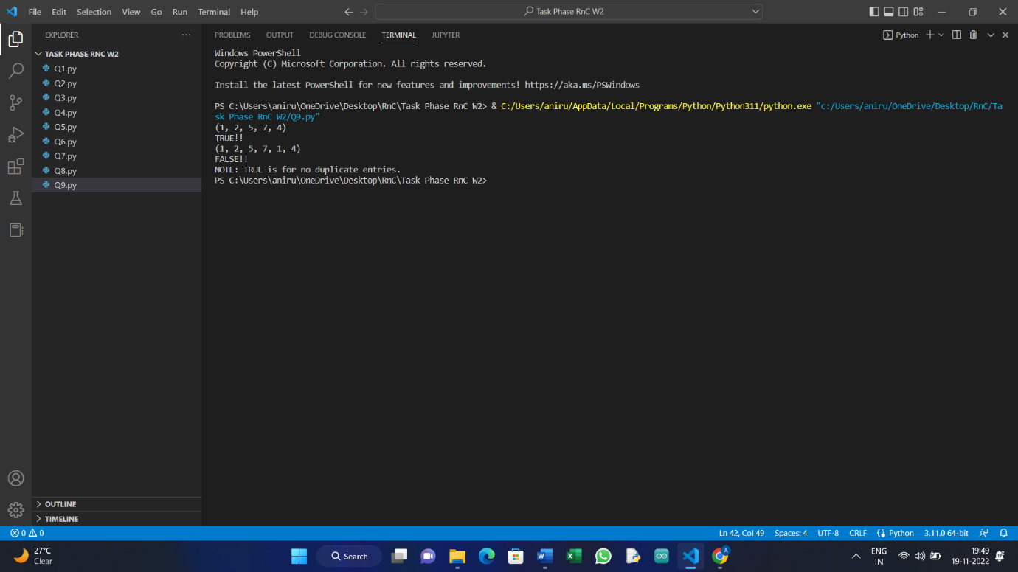

Q10] Generate a random String of given length(take the length from the user). Note: String must be a combination of uppercase and lowercase letters only. Digits and special symbols are not allowed.

#Code:

import string

import random

lst=[]

length=int(input("Enter length of string:"))

x=string.ascii_lowercase

for i in range(len(x)):

    lst.append(x[i])

y=string.ascii_uppercase

for i in range(len(y)):

    lst.append(y[i])

lst2=random.choices(lst,k=length)

print("The generated list is: ",end="")

for i in lst2:

    print(i,end="")

#Output:

